Robotics Process Automation Design and Development (UiPath) – BCG701 Lab
Experiment No: 10
Title: Develop File automation in UiPath StudioX to demonstrate the following activities: Get Folder Info, Folder Exists, For Each File In Folder, Compress/Zip Files, Extract/Unzip Files, Get File Info, File Exists, Create File, Delete File, Copy File, Move File, Write Text File, Append Line.., Read Text File.

Aim: To develop an automation in UiPath StudioX that demonstrates File automation by performing operations such as:
- Get Folder Info
- Folder Exists
- For Each File In Folder
- Compress/Zip Files
- Extract/Unzip Files
- Get File Info
- File Exists
- Create File
- Delete File
- Copy File
- Move File
- Write Text File
- Append Line
- Read Text File

Theory:
- Get Folder Info: The Get Folder Info activity allows you to retrieve and save properties of a specified folder.
- Folder Exists: The Folder Exists activity allows you to check if a folder already exists in the target location.
- For Each File In Folder: The For Each File In Folder activity allows you to take actions on all files within a folder and its subfolders. You can add other activities in the body of For Each File In Folder activity, and all those activities will be executed for every file in the specified folder.
- Compress/Zip Files: The Compress/Zip Files activity allows you to create a compressed file using multiple files or multiple folders.
- Extract/Unzip Files: The Extract/Unzip Files activity allows you to extract the contents of a compressed file to a specific folder.
- Get File Info: The Get File Info activity allows you to retrieve and save specific properties of a specified file.
- File Exists: The File Exists activity allows you to check if a file already exists in the target location.
- Create File: The Create File activity allows you to create a new file in the specified location.
- Delete File: The Delete File activity allows you to delete a specified file.
- Copy File: The Copy File activity allows you to copy a specified file to another location. This activity leaves the original file in place.
- Move File: The Move File activity allows you to copy a specified file to another location. Unlike the Copy File activity, this activity does not leave the original file in place.
- Write Text File: The Write Text File activity allows you to write specified text to a text- based file. if the specified file does not exist, then this activity will first create the file and then write text to the file. also, this activity will always overwrite any text already present in the specified file.
- Append Line: The Append Line activity allows you to add a line of text to the end of a text-based file. The append line activity will not overwrite or delete any text that exists in the file already.
- Read Text File: The Read Text File activity allows you to read the contents (all characters) from a text file.

Conduction:
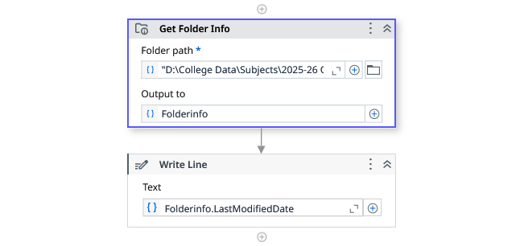

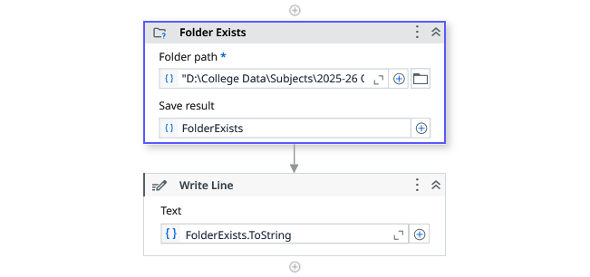

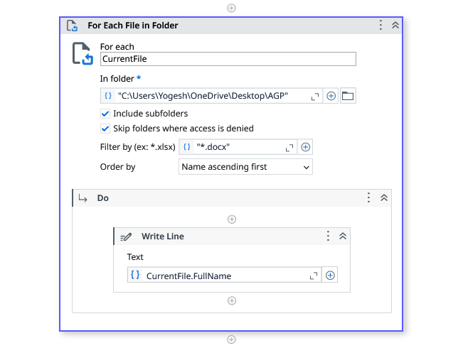

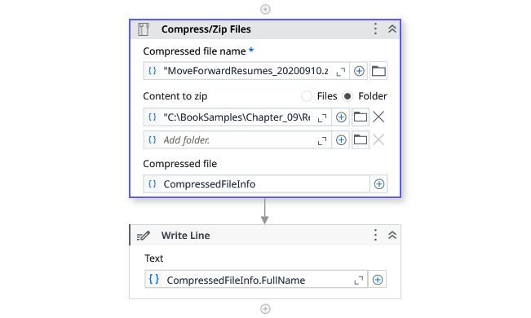

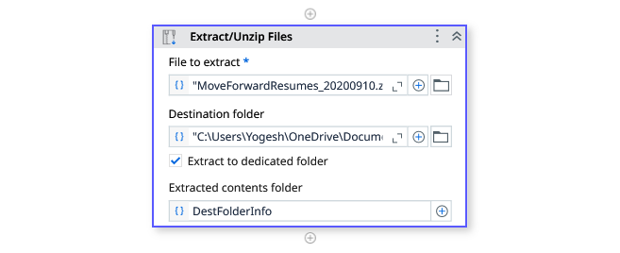

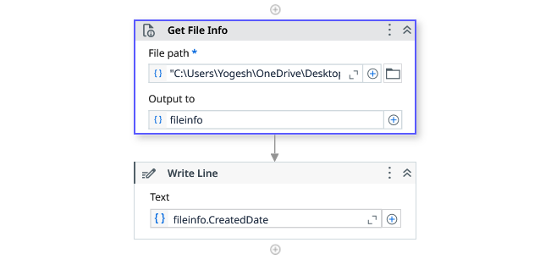

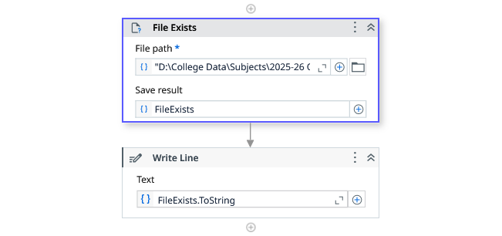
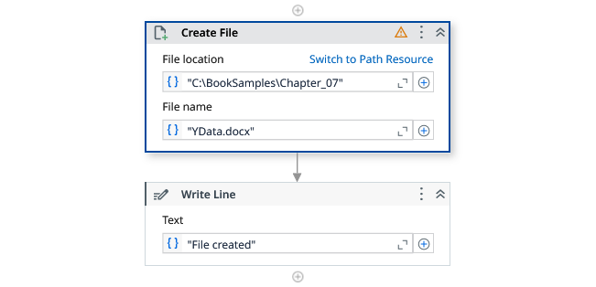
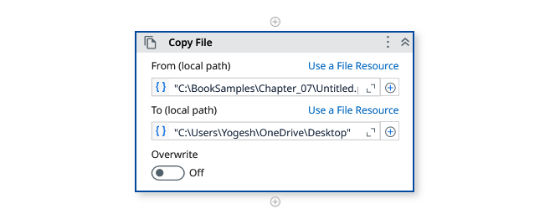
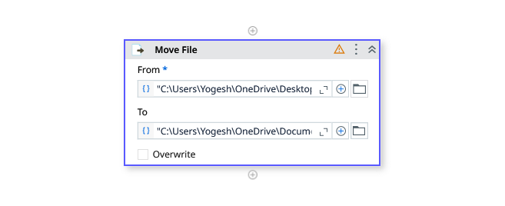

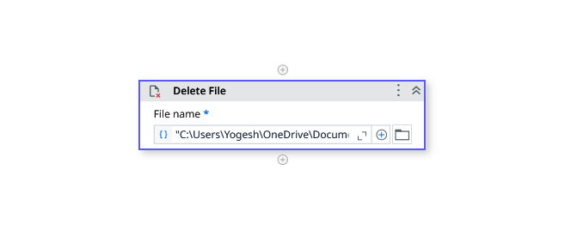
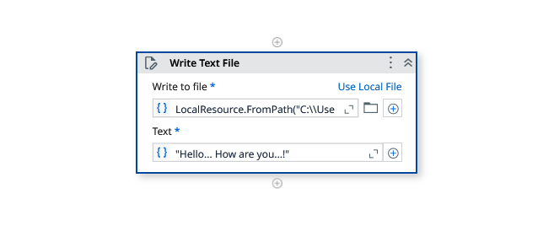
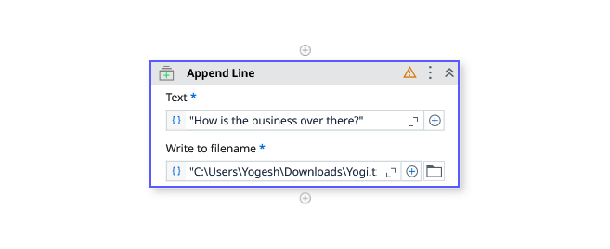
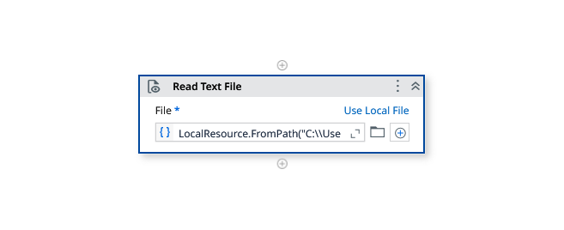
Output:
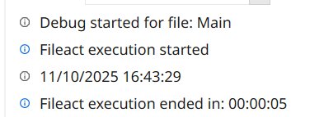
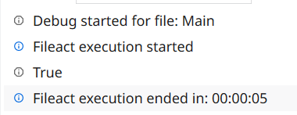

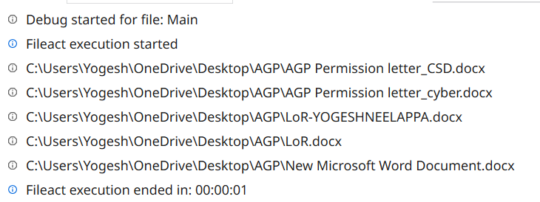

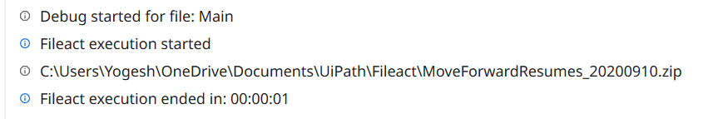

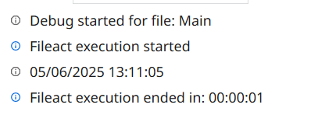

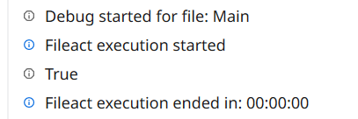

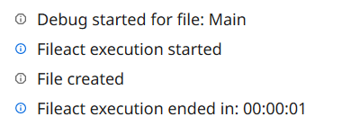

Observation and Results:
The following activities were successfully demonstrated in UiPath StudioX:
- Get Folder Info
- Folder Exists
- For Each File In Folder
- Compress/Zip Files
- Extract/Unzip Files
- Get File Info
- File Exists
- Create File
- Delete File
- Copy File
- Move File
- Write Text File
- Append Line
- Read Text File
The output for the above-mentioned activities is verified.

Evaluation:
Evaluation Parameters | Maximum Marks | Obtained Marks
Conduction | 8
Record Writing | 4
Viva | 3
Total | 15

Signature of the Faculty in-charge with date:

